Name: Gatwech Ruach Karkuon
Date: 28. 08. 2026
Course: Technical Writing for Software Development and Reports

Exercise A: User Manual Procedure
Creating and Activating a Python Virtual Environment
Prerequisites
Before starting, you need:
- A computer with Python installed.
- Visual Studio Code or another code editor.
- Basic knowledge of using the terminal.
- Internet connection for installing packages.
Procedure
- Open Visual Studio Code.
Expected result: Visual Studio Code opens successfully.
- Open the project folder.
Expected result: The project files appear in the Explorer.
- Open the terminal.
Expected result: A terminal window appears at the bottom of Visual Studio Code.
- Create a virtual environment by running python -m venv venv.
Expected result: A folder named venv is created.
- Activate the virtual environment by running venv\Scripts\activate on Windows.
Expected result: (venv) appears before the terminal prompt.
- Install a package by running pip install requests.
Expected result: The Requests package is installed successfully.
- Check the installed package by running pip show requests.
Expected result: Information about the Requests package is displayed.
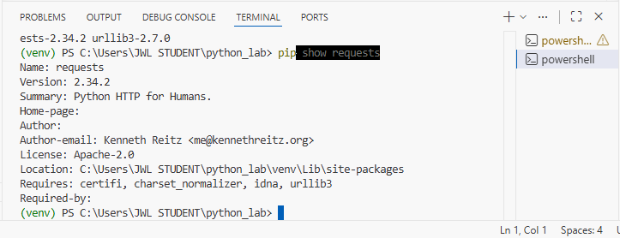
Screenshot: The screenshot shows the VS Code terminal with the Python virtual environment activated as (venv) and the Requests package successfully installed.
Troubleshooting
Problem: The command python is not recognized.
Solution: Make sure Python is installed and added to the system PATH, then restart Visual Studio Code.
Exercise B: API Reference Entry
Create a New Task
HTTP Method: POST
Endpoint: /api/v1/projects/{projectId}/tasks
Description
This endpoint creates a new task inside a project for an authenticated user.
Path Parameter
Parameter | Type | Required | Description
projectId | String | Yes | ID of the project where the task will be created.

Request Body
Parameter | Type | Required | Description
title | String | Yes | Name of the task.
description | String | No | Additional information about the task.
assigneeId | String | Yes | ID of the user assigned to the task.
dueDate | String | Yes | Task deadline in YYYY-MM-DD format.
priority | String | Yes | Priority: low, medium, or high.

Required Headers
Header | Required | Description
Authorization | Yes | Bearer token used to authenticate the user.
Content-Type | Yes | Must be application/json.

Possible Responses
Code | Meaning
201 Created | Task was created successfully.
400 Bad Request | Request contains invalid or missing information.
401 Unauthorized | Authentication token is missing or invalid.
403 Forbidden | User does not have permission to create a task.
404 Not Found | The project or assigned user does not exist.
409 Conflict | Task cannot be created because of a conflicting request.
500 Internal Server Error | An unexpected server error occurred.

Example Request
{
"title": "Complete database design",
"description": "Create the database tables for the project.",
"assigneeId": "USR-1025",
"dueDate": "2026-09-15",
"priority": "high"
}

Example Successful Response
{
"id": "TASK-4582",
"projectId": "PROJ-1001",
"title": "Complete database design",
"description": "Create the database tables for the project.",
"assigneeId": "USR-1025",
"dueDate": "2026-09-15",
"priority": "high",
"status": "open",
"createdAt": "2026-08-28T10:30:00Z"
}

